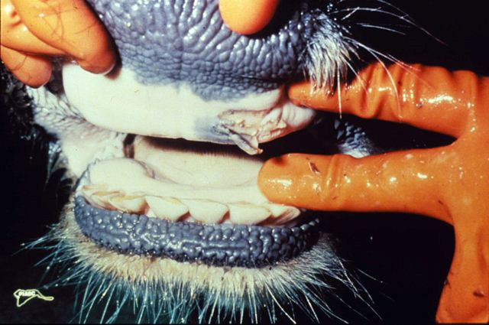

1. **Organ:** Oral cavity

**Lesion:** Ruptured oral blister in diseased cow having erosion.

**Etiology:** *Aphtho virus* (belong to the picorna virus group).

**Diagnosis:** FMD

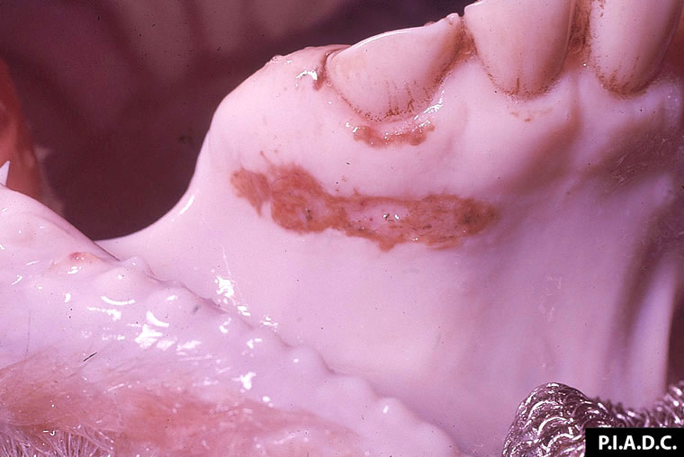

**2- Organ:** Bovine gingiva.

**Lesion:** There is an elongate erosion (ruptured vesicle) ventral to the incisors.

**Etiology:** *Aphtho virus* (belong to the picorna virus group).

**Diagnosis:** FMD

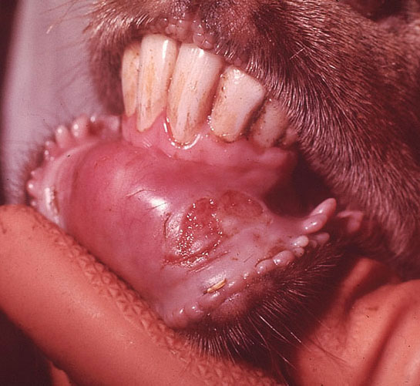

**3- Organ:** Oral mucosa (Goat)

**Lesion:** there is a large, partially re-epithelialized (healing) erosion on the mandibular buccal mucosa.

**Etiology:** *Aphtho virus* (belong to the picorna virus group).

**Diagnosis:** FMD

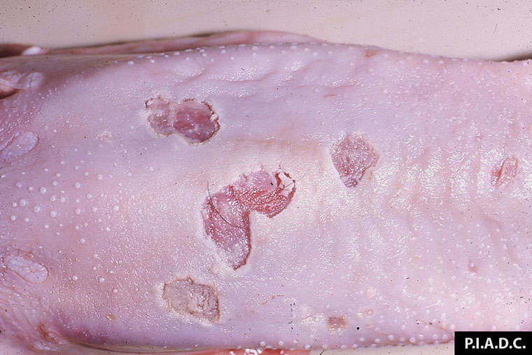

**4- Organ:** Tongue.

**Lesion:** There are multiple large mucosal erosions and ulcers.

**Etiology:** *Aphtho virus* (belong to the picorna virus group).

**Diagnosis:** FMD

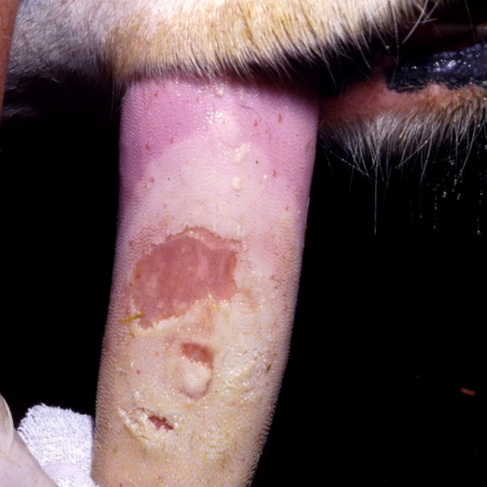

**5- Organ:** Bovine, tongue.

**Lesion:** A large area of undermined epithelium (bulla) is centrally eroded; this lesion probably resulted from coalescence of several smaller lesions.

**Etiology:** *Aphtho virus* (belong to the picorna virus group).

**Diagnosis:** FMD

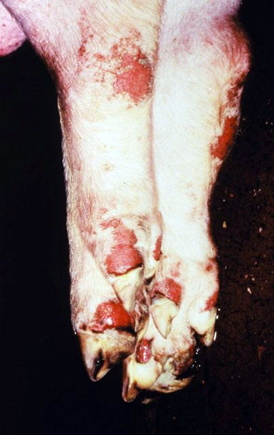

**6- Organ:** feet (pig)

**Lesion:** ruptured blisters on the feet of a pig leaving raw red surfaces.

**Etiology:** *Aphtho virus* (belong to the picorna virus group).

**Diagnosis:** FMD

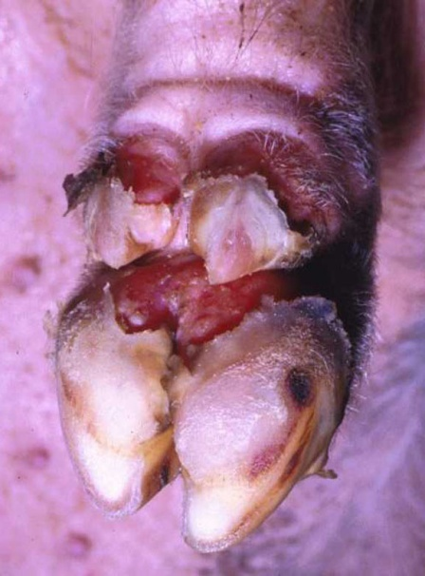

**7- Organ:** Foot (pig)

**Lesion:** Large clefts at the coronary bands precede sloughing of the claws.

**Etiology:** *Aphtho virus* (belong to the picorna virus group).

**Diagnosis:** FMD

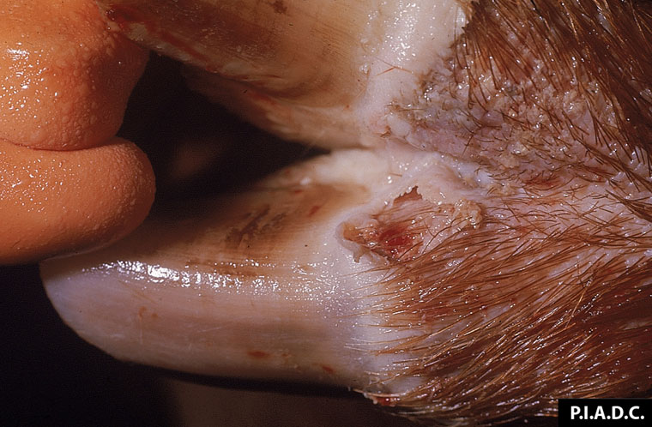

**8- Organ:** Foot (pig)

**Lesion:** A ruptured vesicle of the coronary band extends into the interdigital skin.

**Etiology:** *Aphtho virus* (belong to the picorna virus group).

**Diagnosis:** FMD

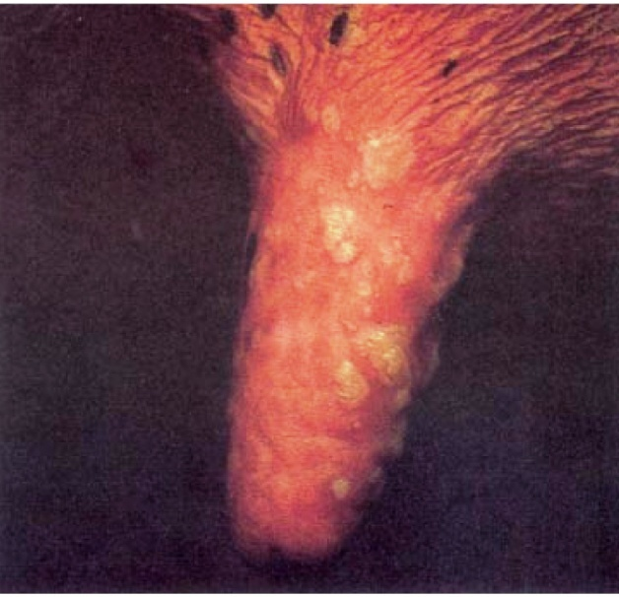

**9- Organ:** Teat (cow)

**Lesion:** One-day-old vesicles on the teat of a cow. Rupturing has not taken place but several vesicles have coalesced.

**Etiology:** *Aphtho virus* (belong to the picorna virus group).

**Diagnosis:** FMD

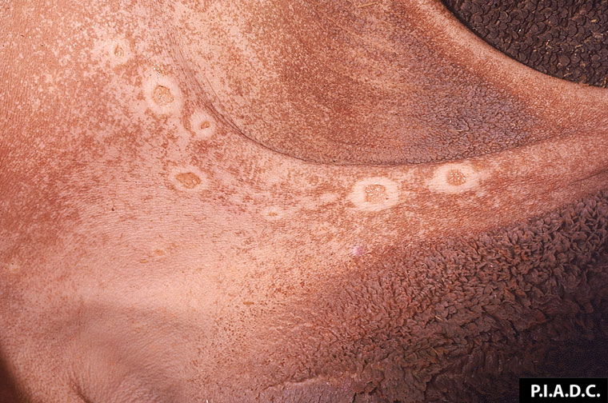

**10- Organ:** Rumen mucosa

**Lesion:** There are several irregularly shaped erosions (ruptured vesicles) on the pillars.

**Etiology:** *Aphtho virus* (belong to the picorna virus group).

**Diagnosis:** FMD

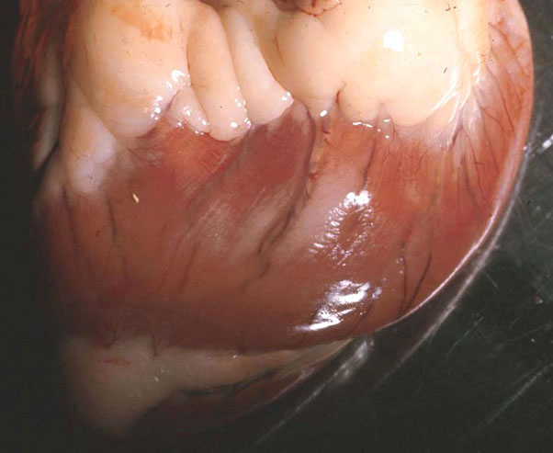

**11- Organ:** Heart (lamb)

**Lesion:** there is a pale area of myocardial necrosis visible from the epicedial surface (Tiger heart).

**Etiology:** *Aphtho virus* (belong to the picorna virus group).

**Diagnosis:** FMD